**OOPS part-1**

1. Write a Java program to swap two variables without using third variable.

Source code:

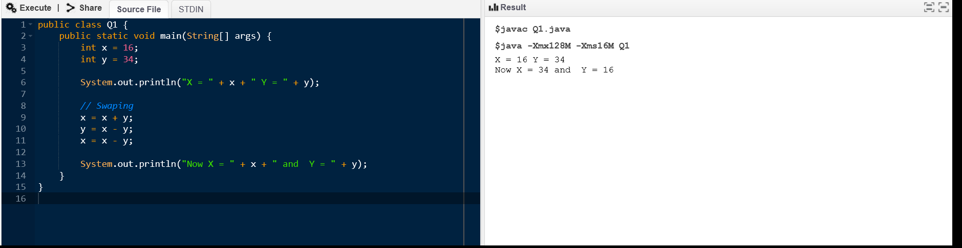

Output:



2. Write a program to find the average of five numbers. The numbers should be entered at run   
time.

Source code:

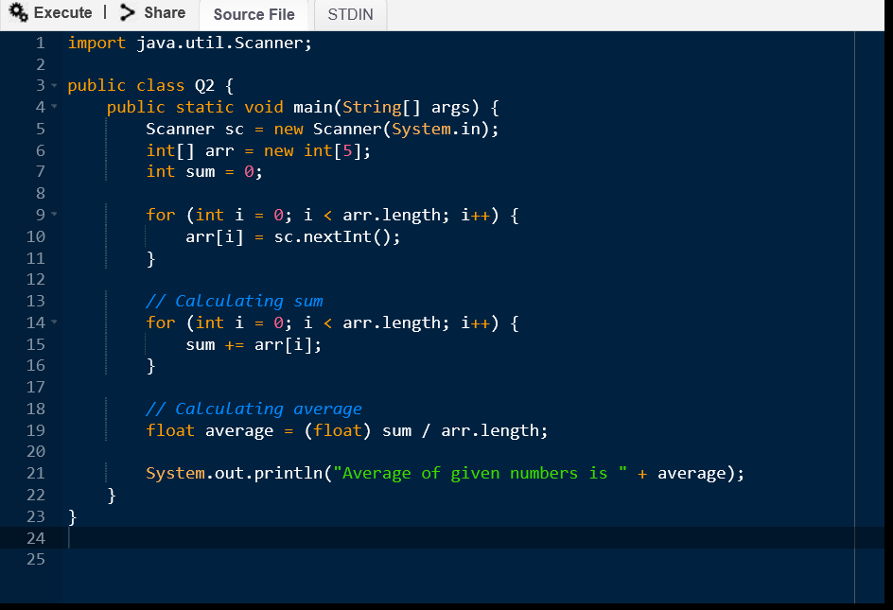

Input:

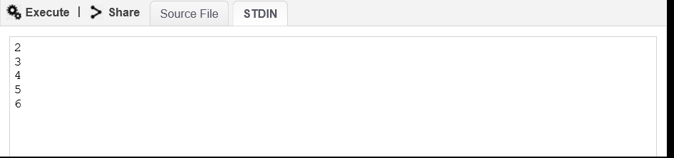

Output:

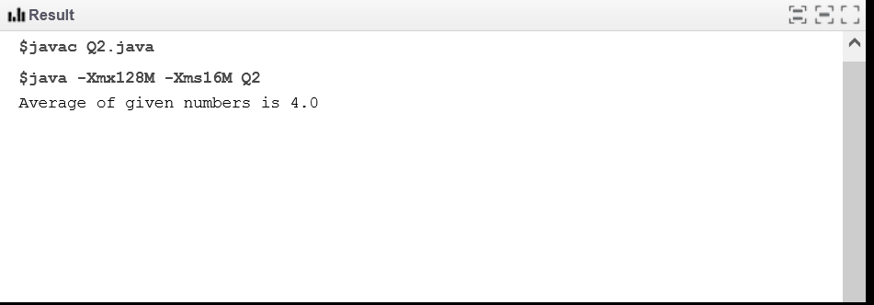

3. Write a Java program that takes two numbers as input and display product of two numbers.

Source code:

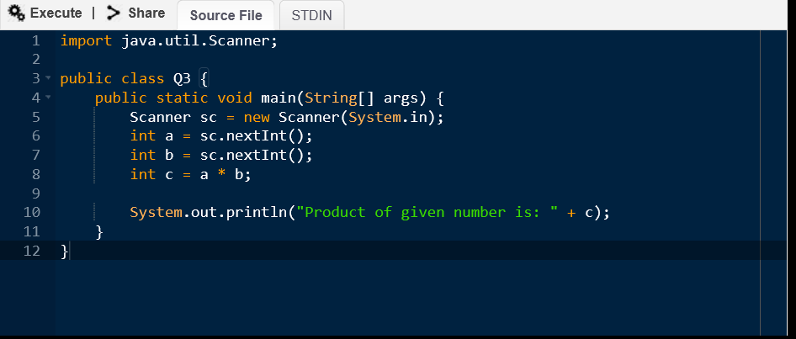

Input:

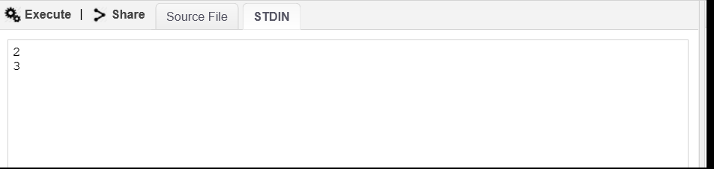

Output:

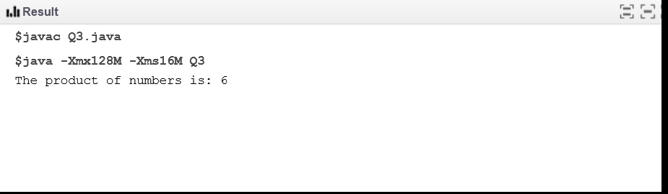

4. Write a java program to create calculator using switch case where two numbers and one   
operator must be entered at runtime.

Source code:

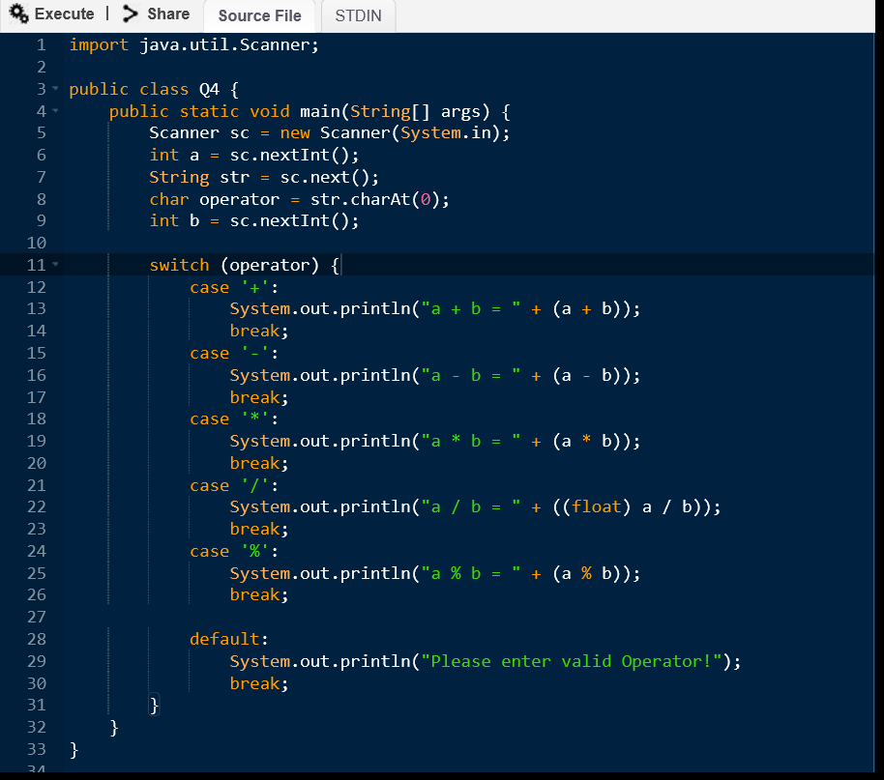

Input:

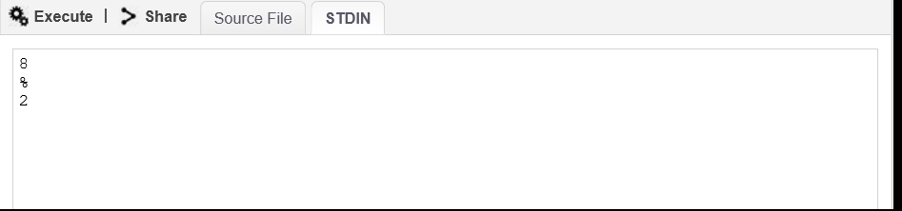

Output:

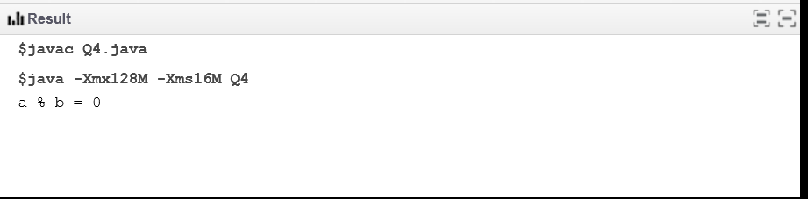

5. Write a Java program to print the area and perimeter of a circle.

Source code:

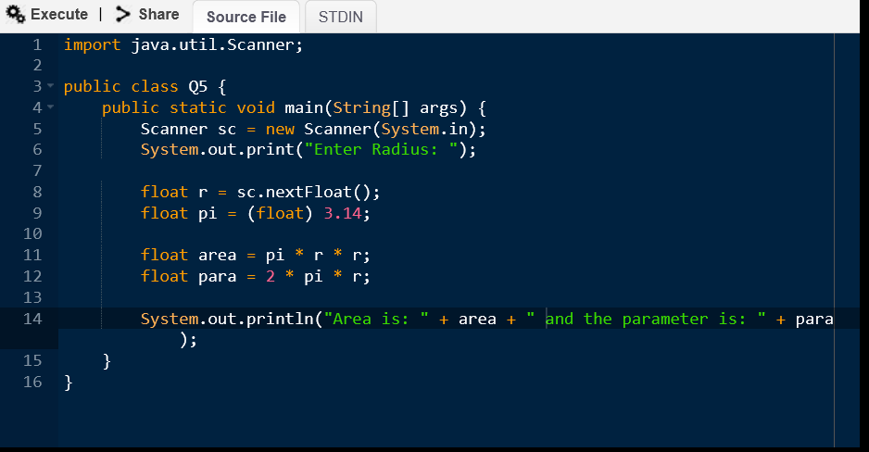

Input:

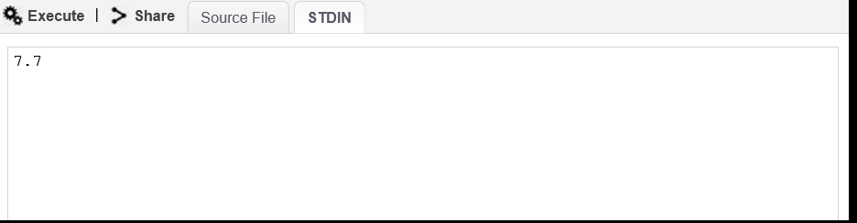

Output:

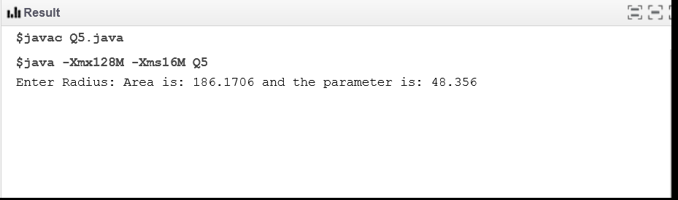

6. Write a Java program to compare two numbers.

Source code:

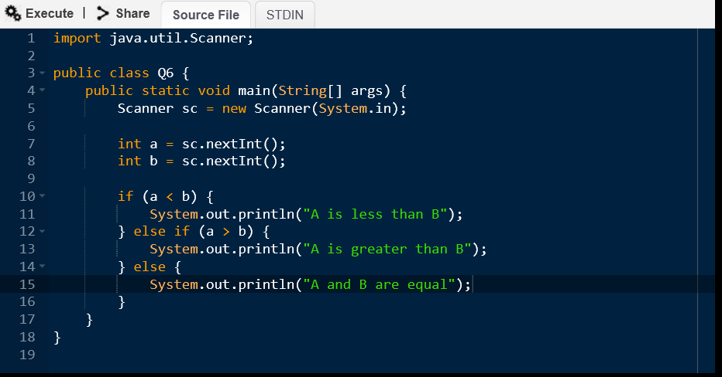

Input:

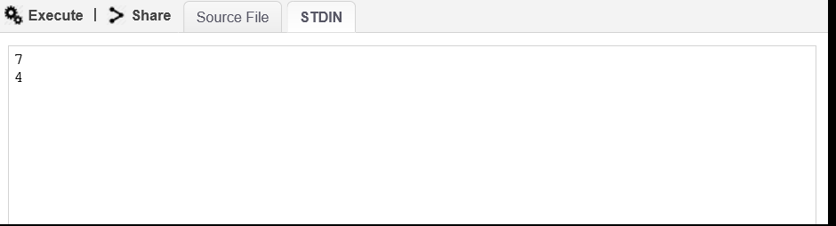

Output:

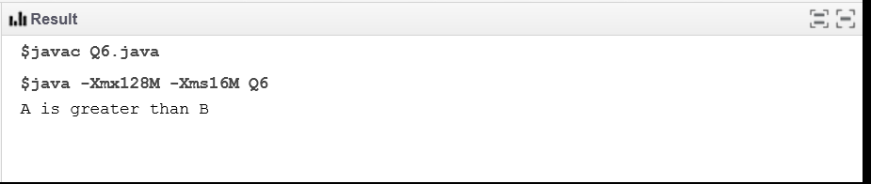

7. Write a java program to check whether Java is installed on your computer.   
Expected Output:   
Java Version: 1.8.0_71   
Java Runtime Version: 1.8.0_71-b15   
Java Home: /opt/jdk/jdk1.8.0_71/jre   
Java Vendor: Oracle Corporation   
Java Vendor URL: http://java.oracle.com/   
Java class path: .

Source code:

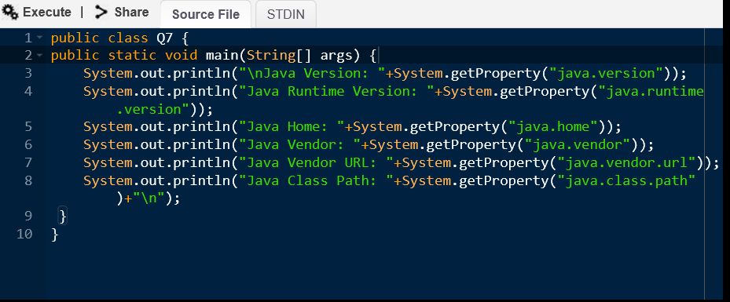

Output:

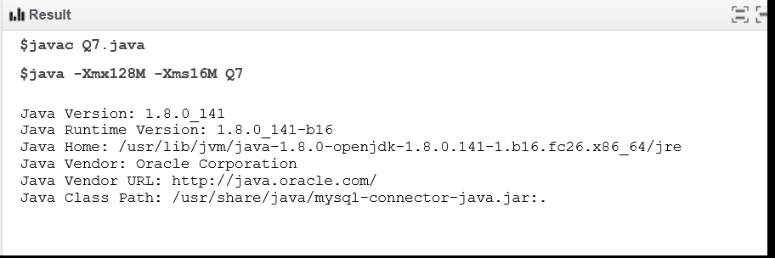

8. Write a Java program that takes a number as input and prints its multiplication table upto 10.

Source code:

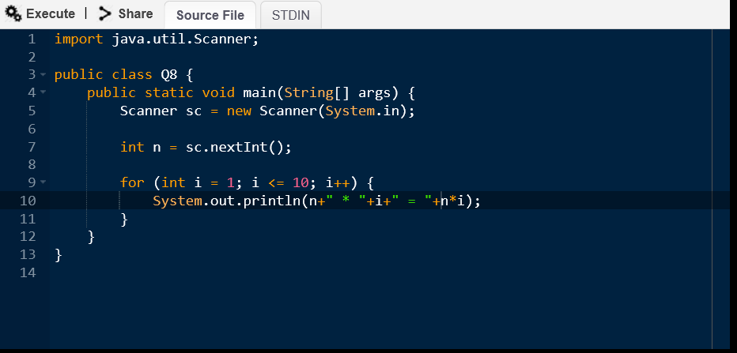

Input:

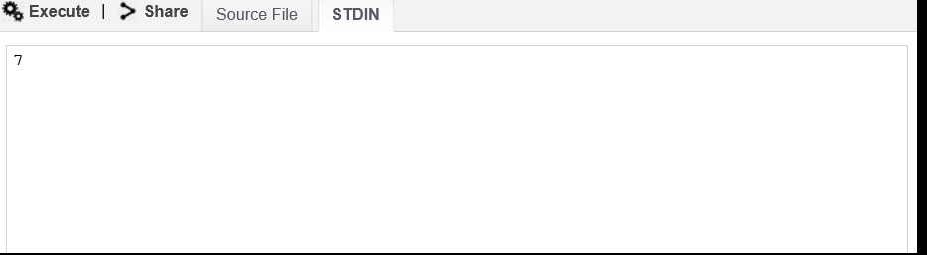

Output:

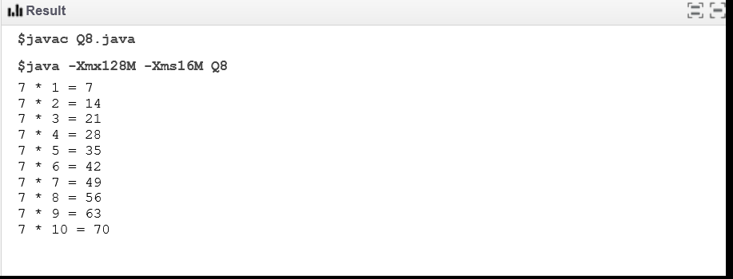

9. Write a java program to check whether the entered number is Armstrong or not.

Source code:

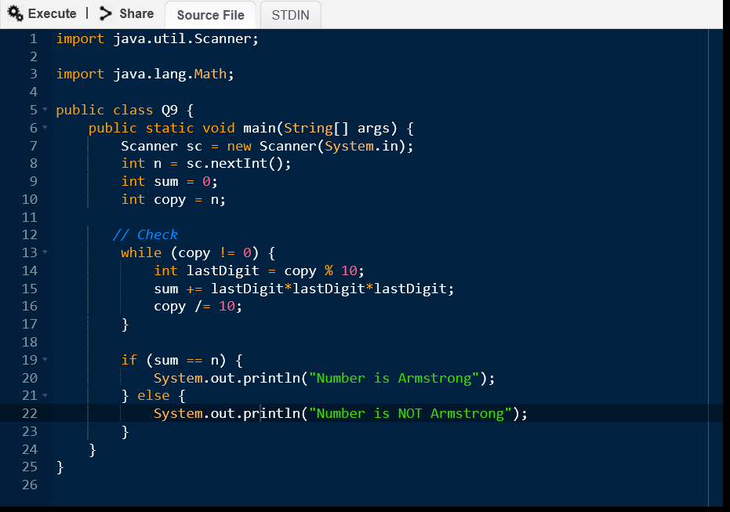

Input:

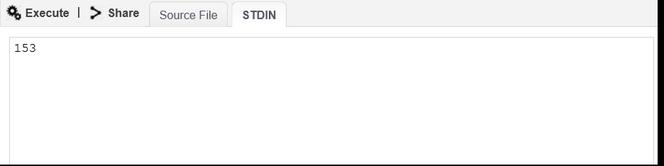

Output:

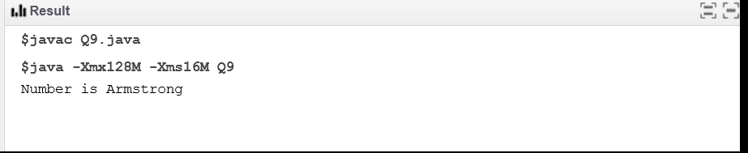

10. Write a Java program to compute the area of a hexagon.

Source code:

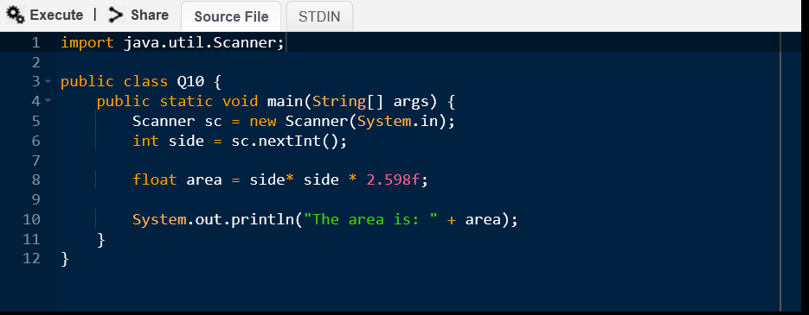

Input:

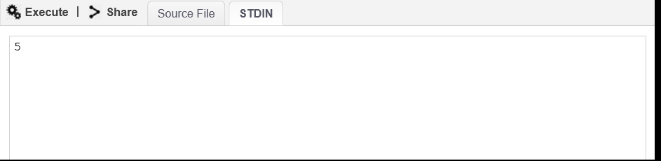

Output:

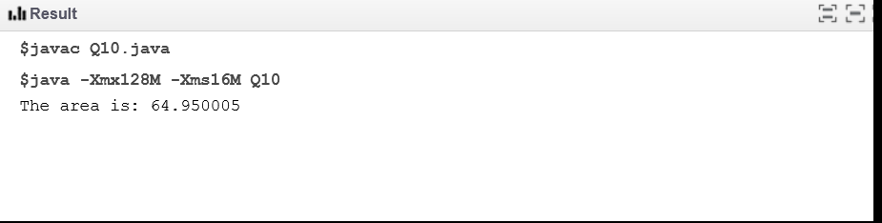

11. Write a program in java to convert temperature from Celsius to Fahrenheit using if -else.

Source code:

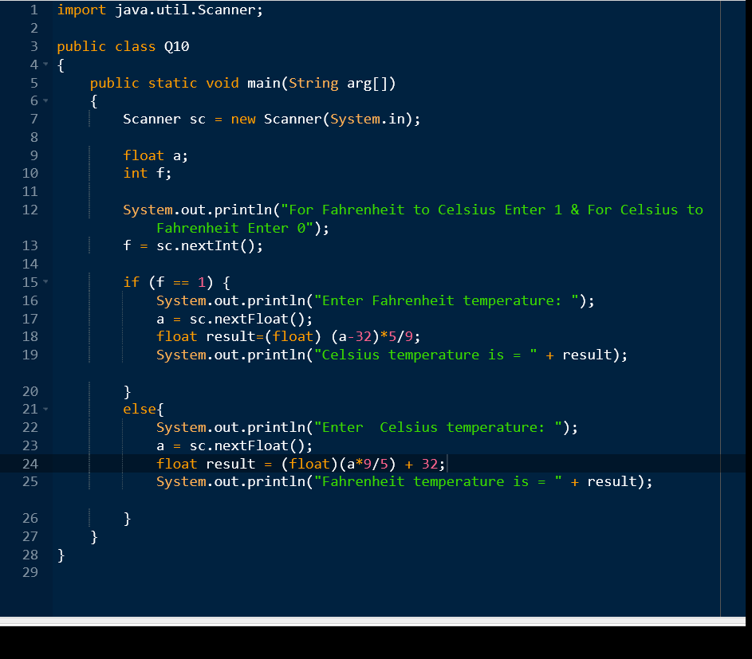

Input:

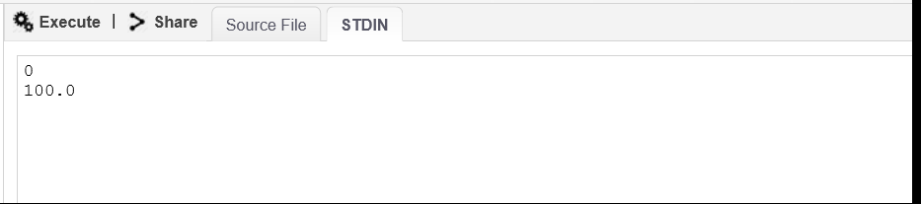

Output:

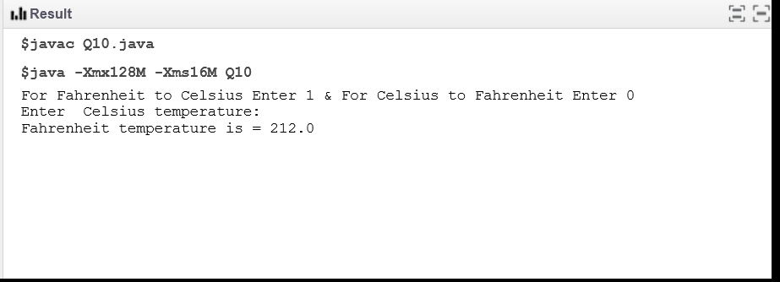

12. Write a java program to calculate the factorial of an integer.

Source code:

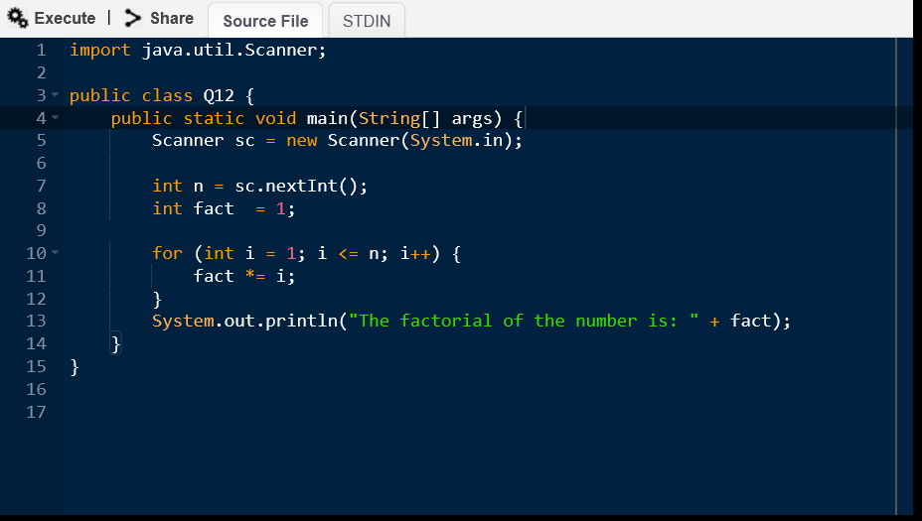

Input:

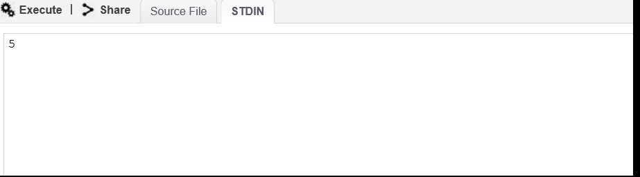

Output:

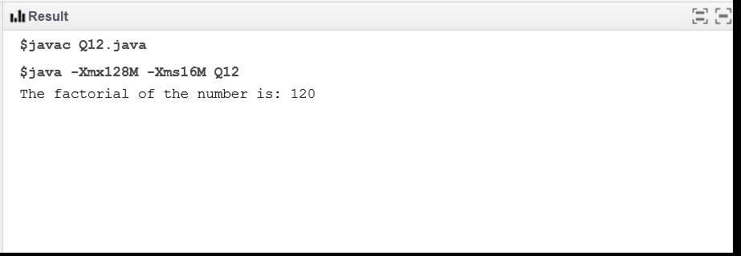

13. Write a java program to compute the sum of the digits of an integer.

Source code:

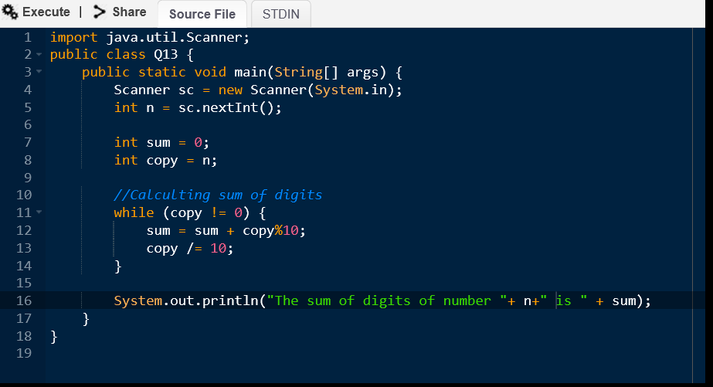

Input:

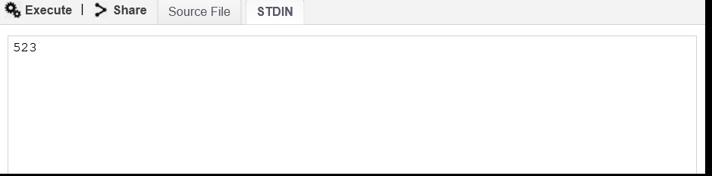

Output:

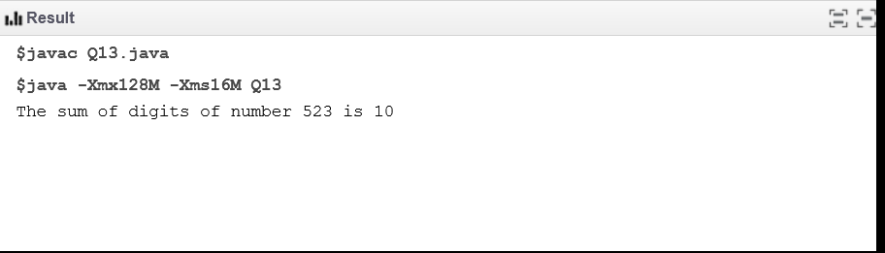

14. Write a java program to print the max value and min value of integer data type.

Source code:

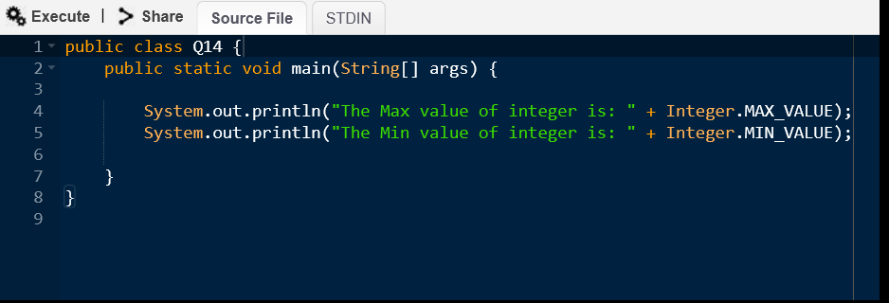

Output:

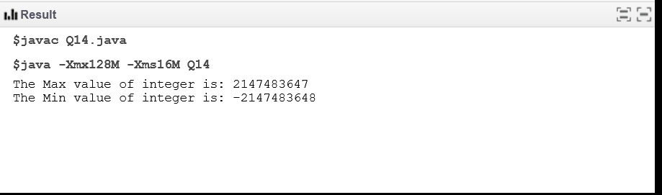

15. Write a java program to take 5 integer number as a command line argument then print the   
average of those numbers.

Source code:

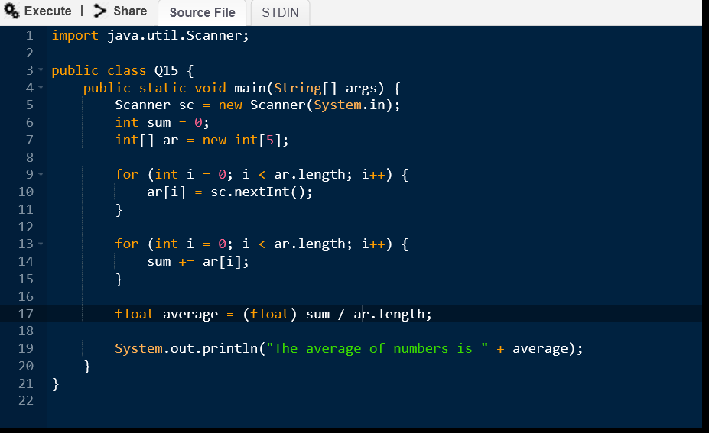

Input:

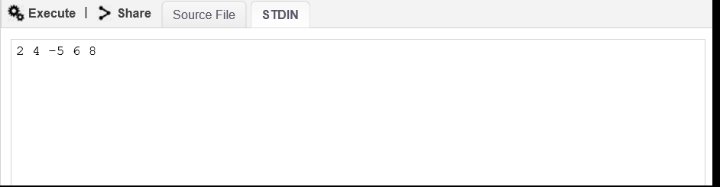

Output:

